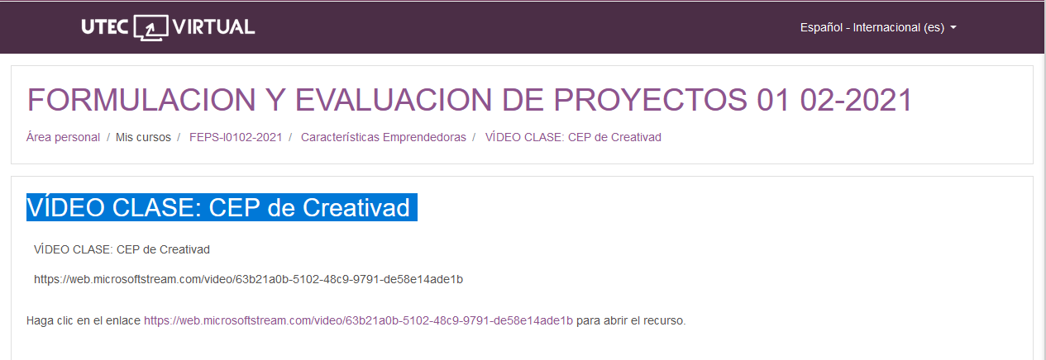

<https://web.microsoftstream.com/video/63b21a0b-5102-48c9-9791-de58e14ade1b>